### CS-639 Building User Interfaces, Fall 2019, Professor Mutlu

# Assignments — Week 13 | Design Experience Prototyping Conversational Interactions

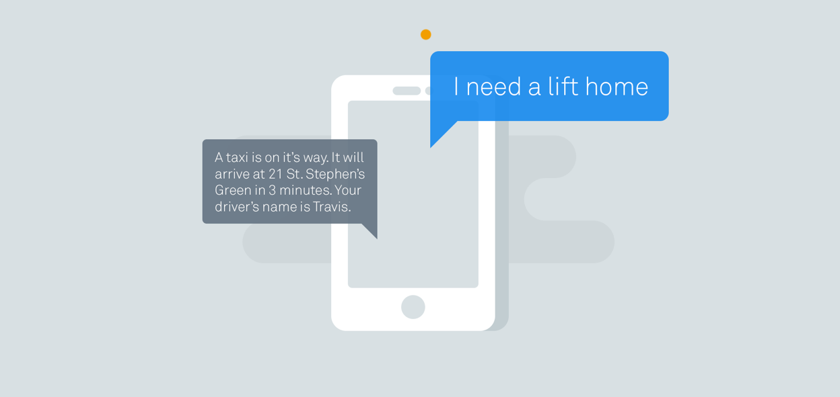

[Image source](https://www.intercom.com/blog/designing-conversational-interfaces/)

In this assignment, you will start your work toward designing and developing your Module 3 deliverable. We discussed in class that designing conversational interfaces has unique challenges and that ideation and prototyping methods that work very well in other design problems do not work well here. The good news is that we are also subject matter experts in conversation, but the bad news is that our expertise is locked into brain mechanisms and is not readily available for us to use, what we called *tacit knowledge*. This is where *experience prototyping* comes into the picture: by simulating the social and/or the physical setting for the interaction and acting out the interactions using methods such as *bodystorming*, we unlock our expert knowledge and apply it to the design problem. In the first part of the assignment, you will engage in experience prototyping of a *conversational shopping assistant*, which will serve as the basis for developing the intents and entities for the first prototype of your Dialogflow implementation.

**Part 1. Experience Prototyping.** In this step, you will follow a process very similar to the process we followed for the in-class activity on experience prototyping, paying particular attention to *bodystorming* for idea generation. In the context of designing a shopping assistant robot, follow the steps below:

1. *Define context —* This is given to you: users interacting with a conversational shopping assistant embedded within a clothing retail website.
2. *Develop scenarios* — Think about how the shopping assistant will help users. What are some tasks the shopping assistant can help users with? Develop 2-3 scenarios.
3. *Identify design goals* — Determine what the shopping assistants can do to assist in these tasks. Consider aspects of the task where the assistant can bring added value. Our goal is not designing a fully autonomous assistant that could take care of everything with minimal input from the user, but what is called a *mixed-initiative design* where the assistant does what it’s good at and the user does what the user is good at.
4. *Set up environment* — You can use the retail store provided with Module 3 starter code and/or another clothing retail store as your environment.
5. *Act out interaction* — Ask a friend, family member, or another student in class to help you bodystorm user interactions with the shopping assistant to develop ideas and to more concrete define user and system behavior and interactions with the environment. Act out at least one interaction for each scenario.
6. *Develop insight* — Capture the conversations from your bodystorming session and any other insight you have gained from the previous step in notes and translate them into a flowchart representation of the interaction.

Your deliverables will be the scenarios and design goals you have focused on, the transcripts of the bodystorming sessions, and a flowchart representation of the conversational capabilities suggested by your experience prototyping. Your flowcharts can be in the form of a graph where the nodes are system behaviors and arrows are user behaviors. You can use a flowcharting application such as [Smart Draw](https://kb.wisc.edu/page.php?id=37841).

<scenarios-and-design-goals>

Scenarios: Buying clothing articles,

Return an item,

Design Goals: Looks for the best price for an item,

Asks for the user size and look for item with availability

Brings up history of commonly bought groceries and asks the user if they want it

Ask if user needs a recommendation after returning an item

<bodystorming-transcripts>

F for friend, A for shopping assistant

Buying clothing articles.

[F] : Assistant, buy a shirt for me.

[A] : Okay, is there any color you are looking for?

[F] : No

[A] : Okay, what size do you want?

[F] : M

[A] : Okay, here’s a list of shirts with M size available, is there any you like?

[F] : Buy the third one on the list

[A] : Okay, here are your options, red, green, blue, yellow, white, black ……

[F] : Anything

[A] : I’m sorry, there is no option called “anything”, would you like to hear the options, again?

[F] : No

[A] : Would you still like to purchase the shirt?

[F] : Yes

[A] : Okay, here are your options, red, green, blue, yellow, white, black ……

[F] : I [sic] do the white.

[A] : Okay, order is placed for a white shirt, [product name] size M.

Returning an item

[F] : Assistant, return a purchase for me.

[A] : Okay, which one? [displays a list of past purchases]

[F] : That one.

[A] : Which one?

[F] : The blue pants.

[A] : Okay, more than one blue pants found, please specify which one

[F] : [product name].

[A] : Okay, the return is started for [product name]. Here is the shipping label, a copy is also sent to your email. Would you like to hear what other users purchase for a blue pants?

[F] : No

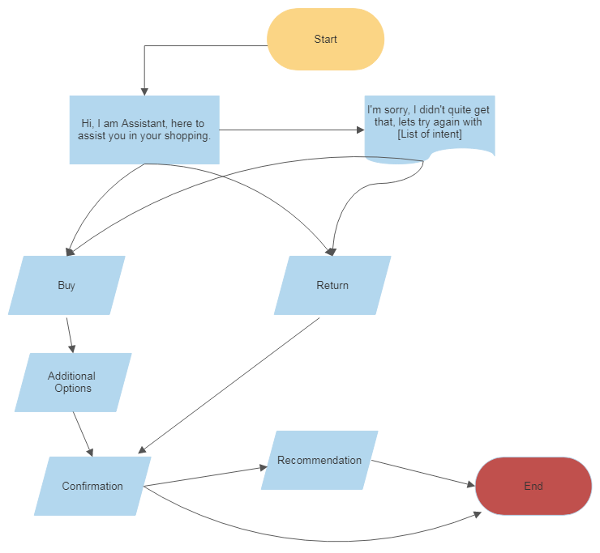<flowchart>

**Part 2. Dialogflow Implementation.** In this step, you will apply what you learned in your Experience Prototyping to the design of the agent you will be creating. More specifically, you will draw on the outcome of your bodystorming session to determine the intents and entities that your agent will utilize in its conversation, and consider how you will use them and server data to provide responses. You will provide three main deliverables:

1. A list of all *intents* you will use (provide 10 training examples for each intent).
2. A list of all *entities* (provide 5 examples for each entity) you will be using with your agent.
3. For each *intent*, write a brief description of what the agent will *say in reply* and what it will *do* to change the GUI.

For a full description of what the GUI can do, and the requirements of the agent, see the [Dialogflow Canvas Assignment](https://canvas.wisc.edu/courses/169115/assignments/688898) and [API readme](https://github.com/wisc-hci-curriculum/WiscShop/blob/master/README.md).

<intents-and-training-examples>

Buy

Could you buy …

Please buy a …

My … is broken

Buy …

Show me a list of …

Get me a …

Search for …

Start Shopping

Shop for …

I would want to shop for …

I’d like to buy …

Return

Start a return

Return …

I want to start a return

Return … for me please

Return … purchased yesterday

Start a return for a purchase yesterday

Show me what I can return

Can I return …

I no longer want …

… is useless

<entities-and-examples>

Time

Today

Tomorrow

Yesterday

Thursday

11 September

Item

Pants

Shirt

Shoe

Sneakers

Cap

Color

Blue

White

Black

Red

Green

Size

S

M

L

Large

40

<intent-responses-and-procedures>

Buy:

Okay, here is a list of possible items that you may purchase [Shows list of products that fits filters]

What color and size do you want it to be? [show possible options of products]

Alright, item added to cart [shows the final choice/product once again]

Return:

Which item do you want to return? [show a list of past purchases]

Would you like to return this item? [Show the chosen item/past purchase]

Return label is sent to the user email. Here is a list of other items that may suit you. [Show similar items]